**Exercise 5: Online Bookstore - Customizing Response Status and Headers**

Business Scenario:

Customize the HTTP response status and headers for the book management endpoints.

1. **Response Status:**

* I used **@ResponseStatus** to customize HTTP status codes for the endpoints in the BookController class.

1. **Custom Headers:**

* I added Custom Headers to the response using ResponseEntity.

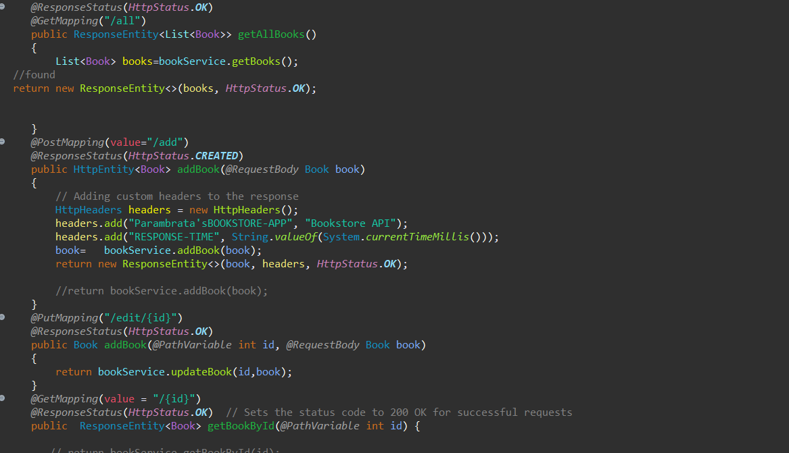

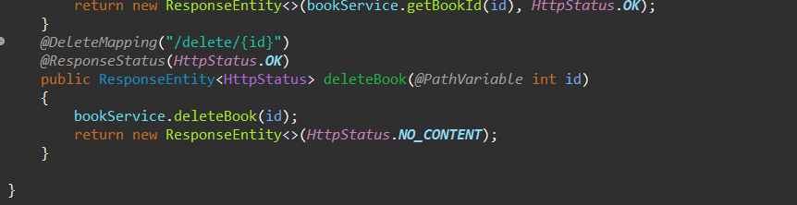

**Output:**

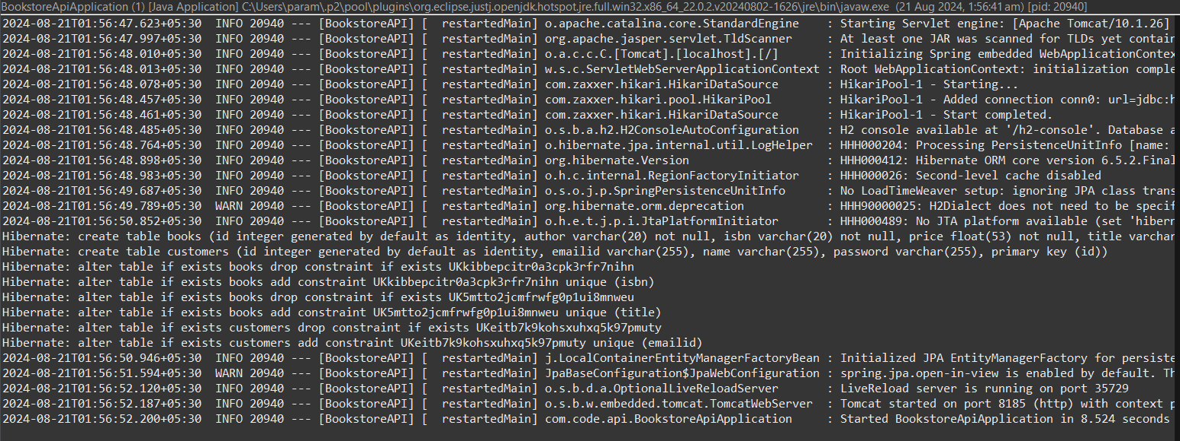

Opening Postman and performing the operations:

Initially, adding a book by POST:

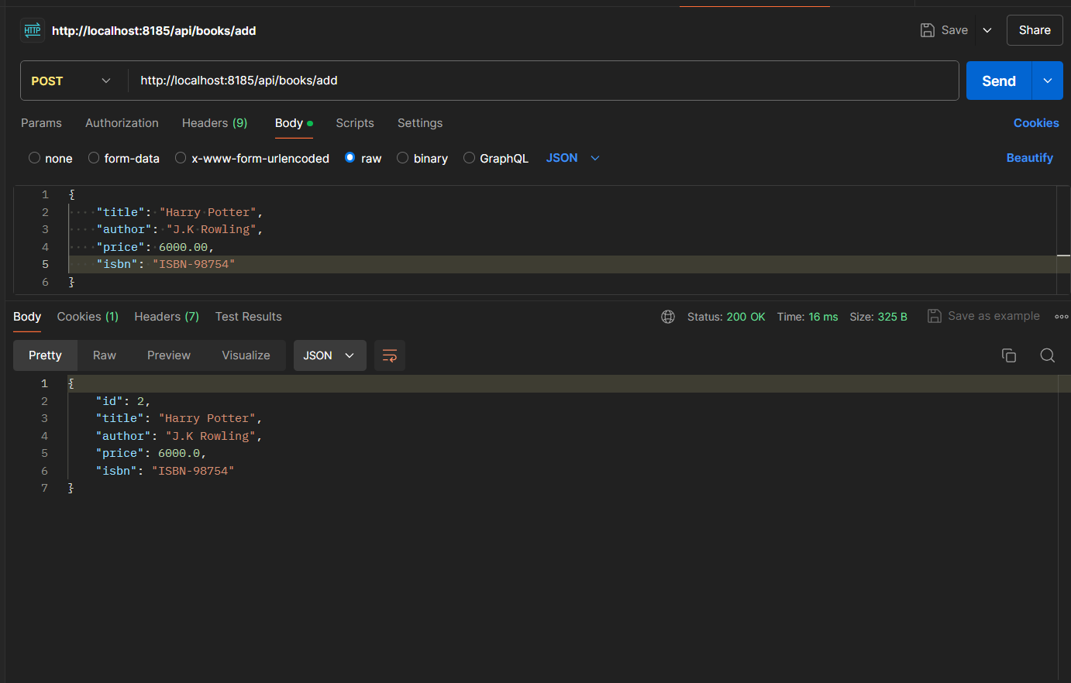

Clicking on Header, Bookstore API is visible:

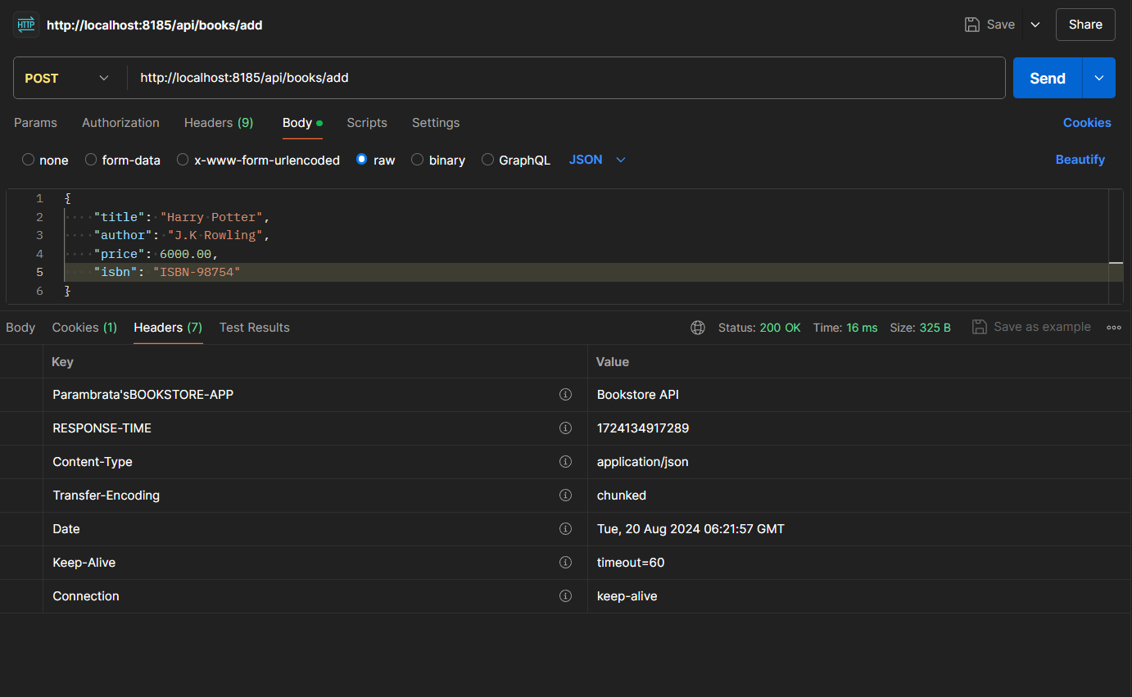

Get by id 1 status 200 Ok:

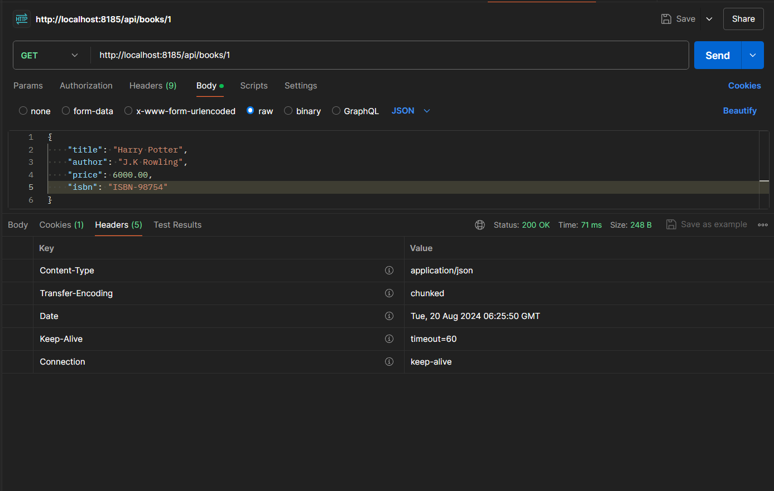

Delete shows 204 No Content:

